PSYC 106: INTRO TO PSYC II
PSYC 206: CHILD DEVELOPMENT
PSYC 208: LIFESPAN PSYCHOLOGY
GLOBAL ASSIGNMENT

Watch the movie “Babies”. This film is available on Netflix, and you may be able to watch it free on HULU. It may also be borrowed from most libraries. The film is a French documentary made in 2010 by the documentarian Thomas Balmes.
The film has no narration. It is a 79 minute exploration of the first year of life (concurrently) for 4 infants from birth until they are one year old. These babies live in Bayanchandmani, Mongolia, Opuwo, Namibia, Tokyo, Japan and San Francisco, the United Sates.
Also, read the review of this movie in the NY Times by A.O. Scott on May 6, 2010.

Then answer the following questions:
- What differences or similarities do you see in parenting style for the different babies?
- What about the place of men or siblings in the different households?
- Can you draw any conclusions about culture affecting development in the first year of life from this movie? Explain.
- Did anything about the portrayal of the babies in the movie surprise you? Explain.
- Do you agree with Scott’s review? What is your own review of the movie.

Note to faculty:
The movie review is attached

Movie Review |'Babies'

Babies (2009)
NYT Critics' PickThis movie has been designated a Critics' Pick by the film reviewers of The New York Times.
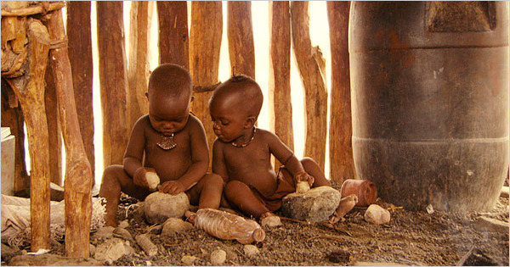
Focus Features
Ponijao, right, is one of four babies featured in the documentary “Babies.”

Awwwwww, Ewwww, Who’s a Good Baby?

By A. O. SCOTT

Published: May 6, 2010
  - The French globe-trotting documentarian Thomas Balmès has taken up a delicate and treacherous assignment in his new film. Fanning out around the world — to the plains of Mongolia, the dusty grasslands of Namibia, the high rises of Tokyo and the streets of San Francisco — Mr. Balmès and his crew set out, about three years ago, to probe a network of mysterious creatures who speak a common idiom barely comprehensible to the rest of us. The film’s subjects are hard to understand and nearly impossible to resist. They project weakness and innocence, yet they also possess almost terrifying powers. And they are just so gosh-darn cute!

- Overview
- New York Times Review

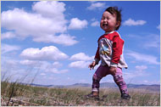Interactive Feature

Babies and Beyond
Frankly, it’s hard to know just what to say about “Babies,” which episodically chronicles the first year in the lives of four far-flung infants. “Awwwwww” would be a start and will no doubt be the sound you hear most frequently from the patrons around you, along with an occasional “ewwww,” a stray gasp of concern or disapproval — you know how anxious and judgmental parents can be — and intermittent laughter. If you have read any child-rearing manuals (or just stared guiltily at a bedside stack of them while dragging yourself toward the squalling bundle of wee-hours need in the next room), “Babies” may be both a puzzle and a relief.
It offers no advice or analysis, no talking-head rumination or voice-over explanation. The occasional snippets of grown-up dialogue are not accompanied by subtitles, which would be superfluous in any case. (But wouldn’t you love to know how to coo “who’s a good baby?” in Mongolian?) “Babies” is exactly what its title promises. It’s babies. And if you love babies you will find it very hard not to love “Babies.”
Is it that simple? I mean, who doesn’t love babies? Why isn’t this just a smattering of YouTube videos (“Baby Pulls Cat’s Tail,” “Baby Eats Banana,” etc.) stitched together into a feature film and accompanied by a peppy musical score? That’s kind of what it is, but the utter accessibility of the movie — even babies will enjoy watching “Babies”! — results as much from Mr. Balmès’s canny formal intelligence as from the intrinsic adorability of his subjects.
Which is not to be denied. Their names are Hattie, Mari, Bayarjargal and Ponijao, and they show themselves to be natural-born comedians, single-minded researchers, action heroes and disciplined workers, each in his or her own special way. They seem to possess distinctive personalities from the very beginning, and as they make their way through infancy, you watch their temperaments grow from bud to blossom.
You also note that while parental love transcends differences of geography and tradition, various cultures cultivate their fledgling members in different ways. Bayarjargal, in Mongolia, is first tightly swaddled and then, as his mobility increases, tethered to his yurt by a long cloth cord. Ponijao, in Africa, crawls about surrounded by a group of women, and her play mimics their daily tasks of grinding meal and preparing food.
In the metropolises of the developed world, Mari (in Japan) and Hattie (in California) are part of a structured world of work and leisure, surrounded by cellphones and computers and exposed to organized group activities that in some cases self-consciously try to mimic the rituals of agrarian and tribal societies.
In the one scene that can be taken as infantile satire, Hattie, at a music class featuring songs of praise to “the earth, our mother,” stands up and makes for the exit, as if fed up with the New Age mumbo-jumbo to which she has been subjected. Another brilliantly funny sequence cuts between Mari’s frustration as she tries to thread a wooden spindle onto a disc with a hole in it and Bayarjargal’s patient wrangling of a roll of toilet paper, which he bites into once it has arrived in his grasp. There is something profound and poignant in these struggles, which illustrate one of the fundamental tasks of babyhood: the mastery of the physical environment.
Other challenges confront these intrepid young travelers on what a philosopher once called the long forced march toward humanity: the aggression (and affection) of siblings and peers; the ways of other animals (cats in particular); the recognition and communication of basic emotions. And though they do their share of crying — they are babies, after all — Hattie, Ponijao, Bayarjargal and Mari all demonstrate remarkable stoicism in the face of a complicated universe. And the ultimate lesson of “Babies,” at least for non- (which is of course to say ex-) babies, is that being small, helpless and brand new is hard.
But hardly impossible. They grow, they learn, and they remind the rest of us of the astonishing power that is our common birthright. We are cast into the world as a bundle of reflexes, unable to focus our eyes, control our limbs or influence our environment in any way. Twelve months later we can walk, kiss, utter basic words and comprehend complicated utterances. It may be downhill from there: a movie called “Adolescents” or, heaven knows, “Grownups,” would hardly be as charming as “Babies.” But “Babies” just might restore your faith in our perplexing, peculiar and stubbornly lovable species.

